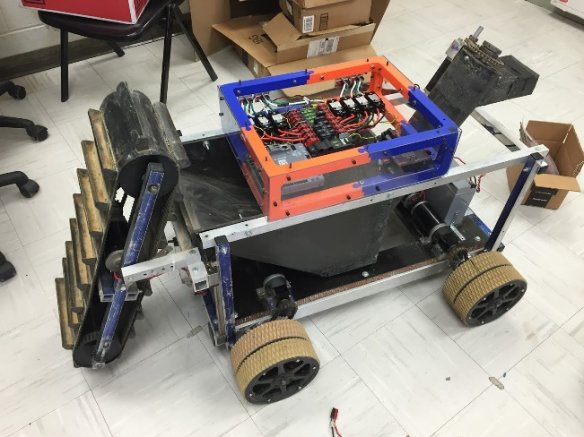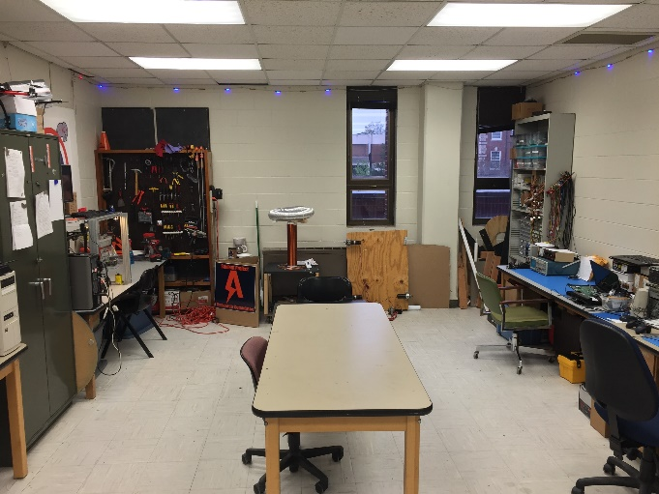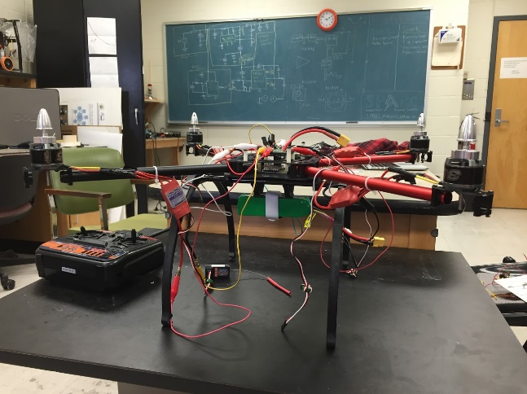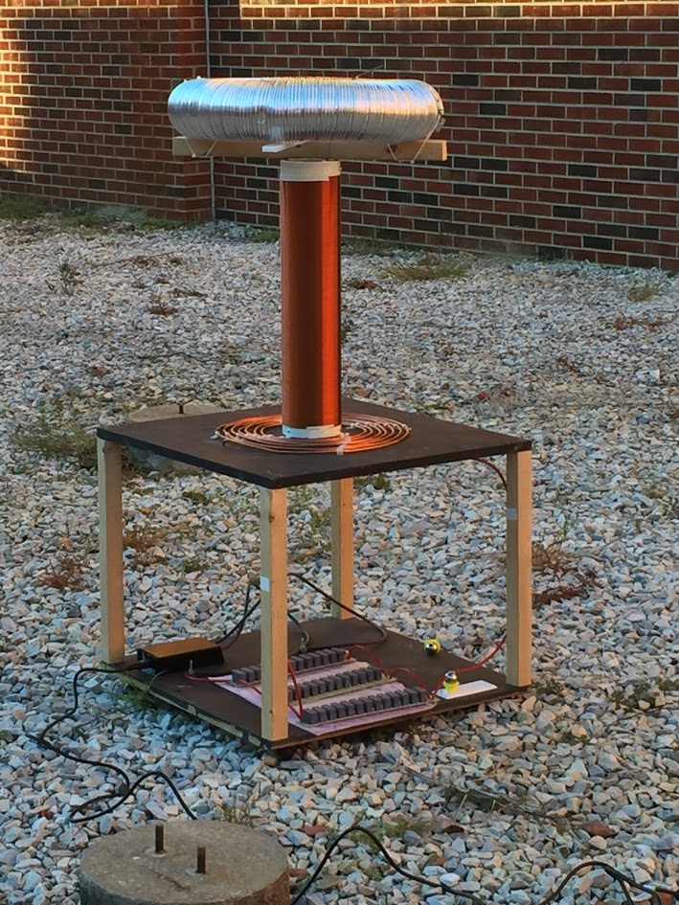

**What is SPARC?**

**→** SPARC stands for Student Projects and Research Committee.

→ It is a student makerspace headquartered in the College of Engineering.

**→** SPARC provides the tools and space for student projects.

**Do you want to...**

**→** Get hands on experience and apply the concepts you learn in your classes?

**→** Learn programming, soldering, fabricating, 3D design, how to operate a 3D printer, and much more?

**→** Build robots, quadcopters, Tesla Coils, or any other project you can come up with?

**Who can join?**

**→** Any student regardless of major or year can join.

**→** No experience is required and scheduling is highly flexible.

https://twitter.com/SPaRC_Auburn

https://github.com/SPARC-Auburn

<http://sparc-auburn.github.io/>

sparc.auburn@gmail.com

**Lab Location:**

Broun 367

**Fall 2016 Meeting Time:**

Thursdays 5:30-6:30 in Broun 235